**By: JuAn Kim**

* Hint: Answer all the following questions in “one word document named properly to reflect your name + course code with section + week of the course + file contents”. You might ask for help or search on the web to make sure you have provided correct answers before submitting your file.

**Part 1:Office 365**Office 365 is a cloud based Software as a Service available atmySeneca.ca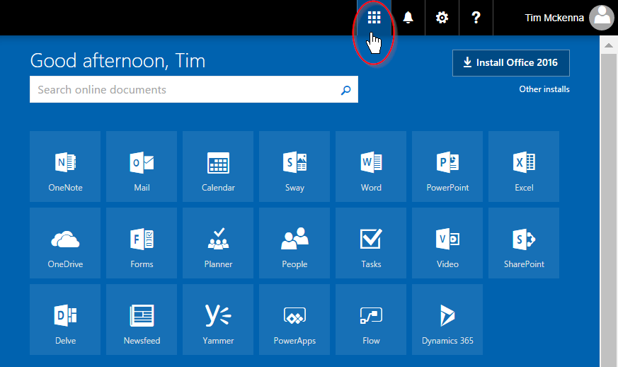  
Create a new OneDrive folder named CPR101. Create a text file (with some sample content) named with your first name + last name and upload the file to the CPR101 folder. <https://inside.senecacollege.ca/its/services/onedrive/sharing.html>

🡺Can you share that Office 365 folder/file with a colleague in CPR101? If so, how? What can your colleague do with that file? How can you collaborate on a single file using Office 365? <https://www.google.ca/search?q=collaborate+on+a+single+file+using+Office+365>. **(15 points)**

Yes, you can share your uploaded folder or file with a colleague or a group. You can do it by clicking the ‘Open OneDrive’ on the main Office 365 page, select(check) the files/folders, click the ‘Share’ button when it appears on a new tab above, and enter a name or email address of a colleague who you want to share your file/folder with.

🡺What are the advantages and disadvantages of storing files “in the cloud” versus on your own system? Issues are data transfer rates, security, limits on file name length, number of files, size of files…anything else?**(15 points)**

**Some of the advantages that Cloud Computing offers are:**

1. Unlimited Storage: The latest cloud computing allows an unlimited storage capacity, so now the users don’t have to frequently delete and update the storage to increase the space availability.
2. Backup Recovery: Storing your files and folders in the cloud is the exact same idea of storing your data on a physical non-volatile device (such as, HDD, SDD, etc). This method makes the backup recovery process much simpler and efficient rather than the old traditional way of purchasing several physical devices to store them.
3. Convenient Access to your data: Wherever you go and there’s an internet, you can always access your information from anywhere and anytime, and your shared partners can also do the same thing.

**Some of the disadvantages of Cloud Computing are:**

1. Security issues: by agreeing the terms and information to use Cloud Computing, you are also agreeing to expose sensitive information to a third-party and you are liable for any damages or losses that may occur. Therefore, you need to choose the most reliable provider whom you can trust and is capable of keeping those information secure.
2. Vulnerable to cyber attack: Hack attacks. Anything you upload or download onto/from the internet is not completely secure.
3. Server/Technical Issues: If your provider experiences a severe server issue or is on the verge of being shut down, all your stored information can be lost or damaged or unavailable until the provider provides the consumers a patch or an update.

🡺Should OneDrive be considered Infrastructure as a Service (IaaS) or Software as a Service (SaaS)? Discuss. **(15 points)**

OneDrive, Drop box or even Google Drive (direct competitors to each other) should generally come under SaaS category. Typically in IaaS, they are the one who have the provision to order the computing capacity like processor and RAM and storage, but SaaS don’t offer those and can only give out the software they make to the customers.

So OneDrive/Office 365 is SaaS because they offer an online version of MS Office, which means, the provider is the one who develops the server OS and other related features as services to the customers.

**Part 2: Product or Service?**“The future is already here. It’s just not evenly distributed.” – William Gibson

🡺Write a reflection on one, some, or all of the following questions for a total of 200 – 250 words. **(35 points)**

***How does © copyright vs https://upload.wikimedia.org/wikipedia/commons/thumb/8/8b/Copyleft.svg/240px-Copyleft.svg.png copyleft change things?***

This debate between the copyright and the copyleft has been going for years now, and it is still one of the most controversial topics in many intellectual property studies. We’ve passed the Licensing Act in 17th century so that we can stop people from taking credits from author’s works, but now in 21st century, there are many who argue that this legal law simultaneously inhibits our creativity and impedes further potential development in author’s produced works.

Mash-up is a good example of the copyleft. There are a ton of famous Youtubers/online song producers who are known famous for their mash-up style remixes. They do dedicate their days and months cutting of thousands of pop, jazz, blues, rock, hip-hop or classic music pieces, and they put them together in order to create a very unique song. They believe and support the idea that public domain should be a place where ideas are free to share, manifest and inspire creative arts/future in this growing digital society. Also, GNU Free Documentation License allows everybody the rights to modify and redistribute the code (as long as the terms are met and remained unchanged in their work), and this eventually has led to a wonderful creation of Linux/Unix that we all know as of today.

**Part 3:**Remember this from Week 3?

*Think about your professional destination after you complete your work here at Seneca: where would you like to go? What skills and knowledge are you going to need when you get there that you don’t have or don’t have enough of? Make a list.*

🡺 Revisit that list and reproduce it here. Thinking of what has happened in the last four weeks in all your courses, what have you done that supports the things on your list. **(20 points)**

In the previous assignment and for that specific question, I have mentioned that I’ve been doing my own personal research on mobile dev, app dev and software dev. Even on the weeks I’ve been away from school, I kept reviewing and revisited all the course materials for midterm preparations (but all midterms were cancelled in the end), and I’ve also been following up with many IT news and updates on IT news websites and such.

I also mentioned about developing time and project management skills, which are very crucial skills that are necessary for many IT jobs. Even though four weeks of out-of- school went by pretty fast, each day was very productive in a way that I planned and organized my daily and weekly schedules and managed to fulfill all those duties I made for myself.